# Analysis

Analysis simply means detailed examination of something. How the project will work, what are the things needed for project, why the project is being made or its target are some things that falls under analysis. Thorough analysis helps to create good strategy plan. Although it’s not that execution of plan will go smoothly but good analysis will help to create less complex situation to carry out the plan and process.

# Analysis Methodology

Different methods as per the scenarios are applied. Here I am going for SWOT analysis.

## SWOT Analysis

It is a strategic planning method that will makes sure to decide whether or not you need to embark on a certain venture or strategy by visualizing advantages and disadvantages.

**Strength:-** Strength is an internal factor. Strength analyses services given by any product, quality, procedures and of course marketing expertise.

User Strength:- User can post their various works and use the application to broaden their base.

Navigation:- The application is pretty easy to navigate since the colors, font size and use of GUI gives user a quick knowledge of what the elements are.

Responsive:- Application is responsive. It can work in any mobile devices.

Tutorials:- Users can learn some basic about arts beforehand.

**Weakness:-** Every projects or products have weaknesses which should be overcome for quality outcome. Weakness is an internal factor.

Offline view:- The application cannot run without internet connection. Offline use of application cannot be done.

Video and photographs restriction:- Although artists can get a quick understanding through videos, however application doesn’t have this feature. Application only focuses on pure art so photographic pictures are not allowed.

Time Constraint:- Application may not be able to be developed in given time period.

**Opportunities:-** It is an external factors. Identifying the opportunities and emerging trends on which we can capitalize is a major part.

Internet Connection:- The application I am working on needs a very good internet connection so users will have the opportunity to get a good internet connection.

Financial gain:- Platform for buying and selling art will give the opportunity to earn. This will help application to be used in high number.

Trends:- Digital art is currently in a trend. People are interested in seeing more digital designs and arts. The application will help them find it easily.

Clueless about arts sales:- Artists of Nepal are still clueless to how their arts will be sold and to whom they will be able to sell. This site will help them solve their problem by giving them platform to do so.

**Threats:-** It also falls under external factors where vulnerability of weaknesses are counted, external factors blocking our progress are analyzed along with other financial threats.

New Competitors:- As market demands goes higher, arrival of rivals are sure things. Their product may outgrowth our product.

Legal Restrictions:- Change in internet privacy and government regulations may lead to inability of using some features of application.

Security Breach:- Growth of hackers may hack your address and may hinder your financial and personnel privacy.

# Feasibility Study

Barriers in project can be due to different factors. Feasibility is a way of doing work conveniently. It is a way to identify if a project is technically, operationally, legally or socially, economically feasible within an expected schedule. Based on how project should be carried out conveniently and what factors affects it, there are some types of feasibility study described below.

**Technical Feasibility**

My project is a web based application. For this I will be using PHP as a programming language. For developing application I used Bracket and SQL which is an open source software and for GUI design for web application bootstrap will be used. The project will be able to run in both smartphones and laptops/desktop. As for using the application, user must have good internet connection.

**Operational Feasibility**

Operation simply means the way of functioning. Here the problem of art for artists will be mentioned and what ArtEstrade will do are analyzed. Reports regarding those analysis will be made.

**Legal Feasibility**

Change in government can be problem of any country. With this change, certain rules, regulations and policy may change. The application in regard to those laws will be updated. There are some terms and conditions user need to be agreed upon.

**Social Feasibility**

Art has yet not been valued in context of Nepal . It’s earning and recognition are not doing well. This app will help them give a way for artists to earn name and some coins. They can easily get their work recognized and can learn many other things from different users. Art is one of the thing that will be ongoing still in coming days so this app will be very helpful for newcomers too.

**Economic Feasibility**

And of course one of the important study is economic feasibility that sees if the outcome is profitable. For the budget of the project no staff were needed, open source software were used, so there were no any expenditures however for the users who will use this can gain some profit.

## Software Requirement Specification(SRS)

SRS is the study of requirement and specifications of the project to be developed. It examines how the project will be developed and how it will works. It includes some functional and non-functional requirements.

## Functional Requirements

It refers to the functional features of the software or hardware. Basically it says what a software does. So it can be calculations, technical details, data operation and processes. Some of the functional requirements of my project are given below.

|  |  |  |  |  |  |
| --- | --- | --- | --- | --- | --- |
| S.N | Requirement No | Requirement Name | Description | Rational | Dependencies |
| 1 | FR1 | Registration | In order to log in to the application user must register | User to log in should make a new account to fully use the application. | N/A |
| 2 | FR2 | Log in | User need to login to use the features of application | After user have registered they can log in and use application. | FR1 |
| 3 | FR3 | Explore work | In order to search the desired work search button is a must | User can search the desired works using search feature. | FR2,FR5 |
| 4 | FR4 | Assist | For any problem or confusion user can go for help so it’s one of the must requirement | In case they get confuse and find problem in using the application help option is there for them as a guide. | N/A |
| 5 | FR5 | Upload art | User should be able to upload their works | user uploads their work to be viewed by many. | FR2 |
| 6 | FR6 | Remark | Users must be able to comment on each other’s works | Comments will also act as a feedback. Users can give their view on each other’s art through it. | FR2,FR5 |
| 7 | FR7 | Availability  Symbol | Users will know about the art sales and sold out information | .If art is already sold out users will know about it. | FR2, FR5 |
| 8 | FR8 | Notify | Users should be able to get notified . | Notifications like comment, watch and likes will be notified to users. | FR2 |
| 9 | FR9 | Cookies | Records information about computers and users. | Tailors user experience, fastens up the process of internet navigation | N/A |
| 10 | FR10 | Settings | User should be able to change their settings desirably. | User may want to change their privacy setting, change password/username or might want to deactivate their account. | FR2 |
| 11 | FR11 | Chat | User can communicate with each other. | To get more information chat box is there to communicate. | FR2 |
| 12 | FR12 | Evaluation | Users can rate each other’s works on the basis of quality and view. | Based on the quality of art and the way it is portrayed users can rate each other’s work. | FR2,FR5 |
| 13 | FR13 | Options for art | Art have its own category. Users can watch desired category of art. | In order to see the art they desire they can chose the type of art in category section.. | N/A |
| 14 | FR14 | Transactions | Users can keep their work on sale while other may buy it. | Users are able to buy and sell art. | FR2,FR5 |
| 15 | FR15 | Forum | Sharing of ideas and views. | Users can discuss over their favorite works and can state their opinions. | FR2 |
| 16 | FR16 | Learning | Acts as a guide in art for users | Learning section will contain some description about those types of arts.. | FR2 |
| 17 | FR17 | Hoard Artworks | User can save up their favorite work or their work. | Gallery option is included to save up the works | FR2,FR5 |
| 18 | FR18 | Manipulate Posts | Users can edit or delete their posts. | Users can make a change in their posts or delete it. | FR2,FR5 |
| 19 | FR19 | Filter Content | Users cannot upload photographs and videos | Admin checks these elements and can block it. | FR2, FR5 |
| 20 | FR20 | Manipulate Account | Users can edit or delete their account | Users could delete their account and also edit it. | FR2 |

## Table 1. Functional Requirements

## Non-functional Requirements

These are the requirements that shows how a system executes its function. It shows the behavior of the system and shows the boundaries in its functionality.

|  |  |  |  |  |  |
| --- | --- | --- | --- | --- | --- |
| S.N. | Requirement No. | Requirement Name | Description | Rational | Dependencies |
| 1 | NF1 | Performance | The application must give a good response | Output of users input should not take much of a time to display. Application should work smoothly without any lag. | N/A |
| 2 | NF2 | Implementation | Application should be able to work in any medium. | It should work on any browser and the 2Ghz processor and minimum of 2 GB RAM should support it efficiently. | N/A |
| 3 | NF3 | Availability | Application should meet the availability target. | Availability target includes service time, recovery time, availability according to geographic regions. | N/A |
| 4 | NF4 | Serviceability | Application should be easy to install, configured and monitored. Should not contain any bugs or faults | Upgrade, recovery of system, a good documentation on app are included in it. | N/A |
| 5 | NF5 | Capacity | It measures the scale of the system. | Increase in hardware, response time given by application, transactions per second. | N/A |
| 6 | NF6 | Data integrity | In terms of my application it means rights context. | For example photographs are restricted my app so admin can go through and block those posts containing photographs. | N/A |
| 7 | NF7 | Usability | Application should be easy to use, easy to understand and easy to navigate. | Interface should be easy to learn(buttons, titles, message box) | N/A |
| 8 | NF8 | Interoperability | It basically means exchange of information between applications, databases, etc. | Application should be compatible in any web browsers, several operating systems and devices(computers, mobiles, tablets) | N/A |
| 9 | NF9 | Security | Unauthorized access control , secure user information | Use of password and username. | N/A |
| 10 | NF10 | Maintenance | Update of application or changes can be done in future | Features can be added or changes in present features can be done. | N/A |

Table 2. Non-functional Requirements

## Moscow Prioritization

Moscow prioritization is all about what must be in your system, what should be, could be and won’t/would. This helps us to list out the more important things that can affect the business or application without it and least important things whose absence won’t make much of a change.

## Moscow Prioritization of Functional Requirements

## 

Table 3. Moscow Prioritization for functional Requirements

## Moscow Prioritization of Non-functional Requirements

## 

Table 4. Moscow Prioritization of Non-functional Requirements

## Hardware and Software Requirements

Hardware and software requirements are necessary to analyze so that hindrance in running application doesn’t come up.

## Hardware Requirements

* Processor Intel(R) Celeron(R) CPU B830 @1.80GHz
* RAM of 6GB
* System Type used is 64-bit operating system, x64-based processor
* Internet connection with a speed of 12Mbps
* Monitor Resolution of 1366x768

## Software Requirements

* Microsoft Windows 10
* Microsoft Word
* Brackets Release-1.13(for Code)
* Xampp win-32-7.3.0-0-VC15-installer
* Microsoft SQL Server Query
* StarUML-v2.8.0

**After Deployment**

**Hardware Requirements for user**

* Processor (CPU) with 2 gigahertz (GHz) frequency or above
* Minimum 2GB of RAM. 4 GB of RAM(Optional)
* Monitor Resolution 1024 X 768 or higher
* A minimum of 20 GB of available space on the hard disk
* Internet connection with a speed of 4 Mbps or higher
* Keyboard and mouse.
* Mobile Devices

**Browsers for application**

* Google Chrome
* Internet Explorer
* Mozilla Firefox

# Use Case

Use case is a simple representation of interaction between user and application or software. It includes some actions users perform while interacting with the application.

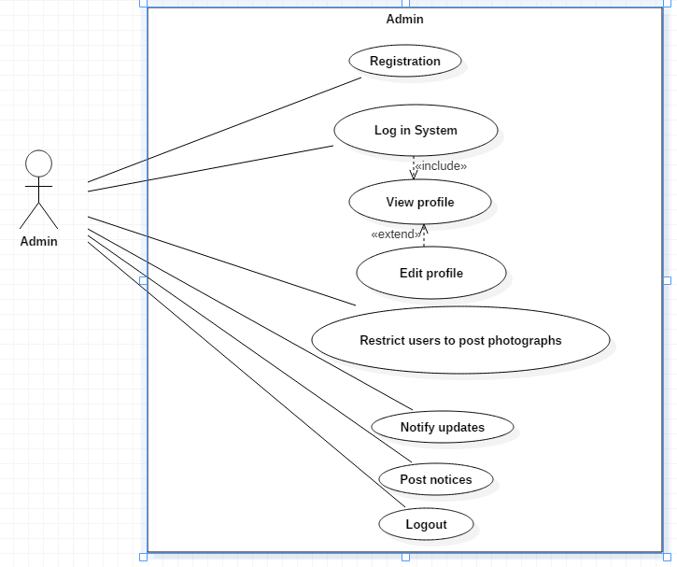

Figure 1. Use Case for Admin

The above use case diagram shows what actions are performed by admin. Admin registers , login to the application, sets their profile. Admin notifies the updates, posts certain notices about what’s going on and what’s coming. Moreover admin has the power to report or block the users who doesn’t follow the application terms. If they want they can log out anytime.

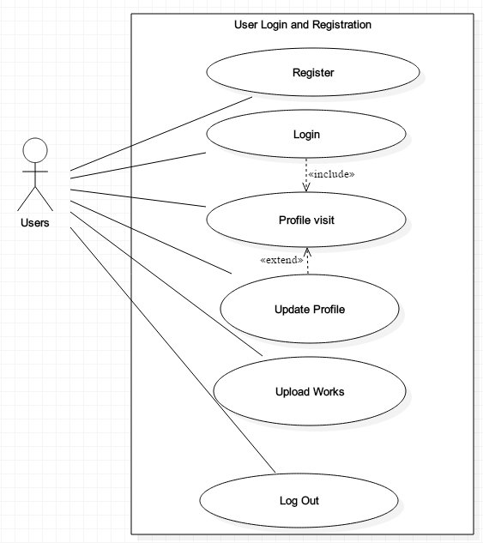

Figure 2. Use Case for Users Registration and Login

Users for log in should register for new account. Users can be anyone be it customer or artists. After logging in they can visit their profile and change the settings they want. They can edit and update the profile whenever they want. Users can upload their artwork and log out whenever they want. There are other things which users can do which are described further.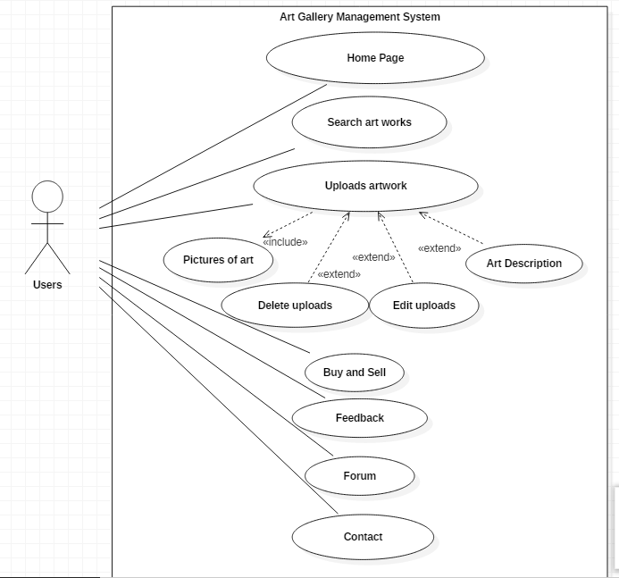

Figure 3. Use Case for Users Activity

Besides that users can go through the features application provides. They can search for their desirable artworks. Furthermore they can upload their artwork. There’s an option for delete or edit their posts if they want. Either they can upload artwork for sales or for views. Many other artists can comment and give their feedback regarding the works. If they want they can also post their opinion on forum section. To get more information they can contact each other through chat box.

# Scenario

To overcome the problems of art in Nepal, I decided to make a web based application regarding art gallery management system whose name is ‘ArtEstrade’. The application will be online based so internet is a must. It will work on some browsers and on mobile devices and laptops/desktop. Users who will use the application must have RAM over 2 GB and processor with minimum of 2GHz. The application will allow users to upload their work either for sales or for views. For that registration and log in are must. However users can still view some features without logged in. Admin can restrict the user to do some action that are not mentioned in the application terms. Besides that users can manipulate their uploads and profiles. Application have some essential features like comment box for feedback, chat box for communication and notifications to notify users . Besides that it also includes some other common features too.

# NLA

ArtEstrade is an web application focusing on building a platform for artists to share and sell their arts. The application will give users diff range of options. The registration for the app is free, artists can buy and sale their arts and offers series of categories and features.

The application includes some parts like

User Login

Admin Login

Art in sale

About Us

Contact info

Uploads

Notifications

User and admin indicates us whereas rest of the parts are the classes of the system

**NLA**

**Candidate Lists**

|  |  |  |
| --- | --- | --- |
| Art | Web | Processor |
| Application | Mobile | Minimum |
| Art | Devices | Users |
| Gallery | Laptops | Sales |
| ArtEstrade | Desktop | Views |
| Application | Users | Registration |
| Internet | Application | Log in |
| Users | Admin | Action |
| Browsers | RAM | Features |
| terms | Profiles | Uploads |
| Features | Comment box | Feedback |
| Chat box | Communication | Notifications |
| Users | Common | Features |

**Potential Verbs**

|  |
| --- |
| Make |
| Use |
| Uploads |
| View |
| Restrict |
| Do |
| Mentioned |
| Manipulate |
| Includes |

# Class Diagram

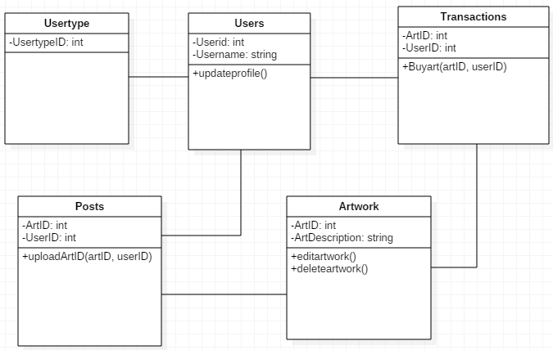

Figure 4. Class Diagram of ArtEstrade

Above is the class diagram for my project made using StarUML. Here users can be either admin or artist. User can update their profile whenever they like. User uploads art either for view or for sales while other users can buy that art. After one art is sold same art cannot be bought by another user. Further users can edit their uploaded art or delete it.